### E-COMMERCE WEBSITE

**PROJECT REPORT**

**Submitted by**

**Arungarai selvan E(20BIT072)**

**Sabarisharan K (20BIT084)**

**Saravanan V(20BIT086)**

**in partial fulfillment for the award of the degree of**

**Bachelor of Technology**

**in**

**Information Technology**

**Dr. Mahalingam College of Engineering and Technology Pollachi - 642003**

**An Autonomous Institution**

**Affiliated to Anna University, Chennai - 600 025**

**MAY 2022**

**Dr. Mahalingam College of Engineering and Technology, Pollachi - 642003**

### An Autonomous Institution

### Affiliated to Anna University, Chennai - 600 025

**BONAFIDE CERTIFICATE**

Certified that this project report, **“E-Commerce Website”**

is the bonafide work of

**Arungarai selvan E(20BIT072)**

**Sabarisharan K (20BIT084)**

**Saravanan V(20BIT086)**

who carried out the project work under my supervision.

**Ms.G.Saranya, AP/IT**

Project Guide

Information Technology

Dr. Mahalingam College of Engineering and Technology, NPT-MCET Campus

Pollachi – 642003 India

**Dr. S. Ramakrishnan** Professor & Head Information Technology

Dr. Mahalingam College of Engineering and Technology, NPT-MCET Campus Pollachi – 642003 India

Submitted for the Autonomous End Semester Examination Project Viva-voce held on

**INTERNAL EXAMINER EXTERNAL EXAMINER**

# ABSTRACT

### E-COMMERCE WEBSITE

**ABSTRACT**

E-Commerce is the electronic commerce or the buying and selling of anything through network preferably over internet nowadays. E-Commerce came into existence during the 1900’s with the developing sector of computers. Developing countries use E-commerce as their crucial form of development by implementing B2B i.e., Business to business commerce strategy. An e-commerce website which will run based on the global standard for global usage of shopping have been designed. The growth of e-commerce has gradually hindered the security and its importance. So here comes another updated version of secured shopping. Highly encrypted page of safe check out system and payment regulations. This project is about the creation of an E-Commerce website using open-source package tools of PHP language, MYSQL database, and Apache web server. This application runs based on two views – Admin view and the public (client) view. In this project the extra features added on the website apart from existing system are smoother performance on admin and client panel. Bigger upgradation on the client-side interaction with admin and sellers, embedded it to the webpage using tawk.to software which is very much user friendly.

**ACKNOWLEDGEMENT**

### ACKNOWLEDGEMENT

Apart from the efforts, the success of this project depends on the encouragement and guidelines of many others. We take this opportunity to praise the **almighty** and express our gratitude to the **people** who have been instrumental in the successful completion of our project.

We wish to acknowledge with thanks for the excellent encouragement given by the management of our college and we thank **Dr. C. Ramaswamy, M.E., Ph.D., FIV, Secretary, NIA Educational Institutions** for providing us with a plethora of facilities in the campus to complete our project successfully.

We wish to express our hearty thanks to **Dr. A. Rathinavelu, MTech., Ph.D., Principal**

of our college**,** for his constant motivation regarding our project work.

We heartily express our extreme gratefulness to **Dr. S. Ramakrishnan, M.E., Ph.D., Professor& Head of the Department, Information Technology** for his instrumental in providing such wonderful support to us.

It is our primary duty to thank our **Project Coordinator, Mr. N. Praveen Sundra Kumar, M.E., Assistant Professor, Information Technology,** who is the backbone of all our project activities, for their consistent guidance and encouragement, which kept us fast and pro-active in our work. It is their enthusiasm and patience that guided us along the right path.

We would like to show our greatest appreciation to our **Project Guide,** **Ms.G.Saranya, AP/IT**.We feel motivated and encouraged every time we attend her meeting. And the guidance from her broadens our minds to do the project with interest and enhanced knowledge to know more.

Finally, we extend our heartfelt thanks to the enriched motivation and encouragement of our **parents, friends, and faculty members.** The facilities received from our institutions made our work easier. We are grateful to everyone who constantly helped and supported us to complete the project enthusiastically and successfully.

# TABLE OF CONTENTS

### TABLE OF CONTENTS

#### Chapter No.

**Title Page No.**

Abstract i

Acknowledgement ii

List of Figures iii

List of Abbreviations iv

1. INTRODUCTION 1
   1. 1 Problem Definition 2

1. 2 Project Overview/ Specifications 2

1. 3 Hardware Specification 2

1. 4 Software Specification 3

1. EXISTING SYSTEM 4
   1. Existing System 5
   2. Limitations in existing system 5
2. PROPOSED SYSTEM 6
   1. Proposed methodology 7
   2. Process flow diagram 8
3. RESULTS 10

4.1 Application areas 11

1. CONCLUSIONS 12

5.1 Future Works 13

1. REFERENCES 14

6.1 Web References 15

1. APPENDICES 17
   1. Appendix-1 17
   2. Appendix-2 19

# LIST OF FIGURES

|  |  |  |  |  |
| --- | --- | --- | --- | --- |
|  | **LIST OF FIGURES** | |  | |
| **Figure No.** | **Title Page no** | |
| Fig 1 | Process flow diagram 8 | |
| Fig 2 | Process flow and functionalities 8 | |
| Fig 3 | Outcome webpage implementation 17 | |  | |
| Fig 4 | Admin control panel and options 18 | |  | |
|  |  | | |  | |
|  |  | | |  | |
|  |  | | |  | |

# LIST OF ABBREVIATIONS

### LIST OF ABBREVIATIONS

CSS - Cascading Style Sheets

HTML - Hyper Text Markup Language

JS - JavaScript

PHP - Hypertext Preprocessor

SQL - Structured Queried Language

# CHAPTER 1 INTRODUCTION

**1.INTRODUCTION**

E-Commerce i.e., electronic commerce is the purchasing and selling of goods and services through a big band of networks or Internet. Now the modernization in technology and their advancements led this project for people to access every product in a single window of the internet.

**1.1. PROBLEM DEFINITION**

People of the 21st century have evolved a lot in time saving thus purchasing and shopping of their needs through online. And thus, people avoid going physically for shopping. So, there is a need of online advancement in shopping.

**1.2. PROJECT OVERVIEW AND SPECIFICATIONS**

Creating the website's User Interface (UI) using HTML, CSS and enhancing it further using Bootstrap; without implementing any of the websites 's core features. Implementation of animations, effects and core functionalities (e-commerce shopping) using JavaScript. Publish to GitHub and host your project live using PHP admin and XAMPP for local testing, whereas on global launch host the website over Netlify.

**1. 3. HARDWARE SPECIFICATION**

#### Disk Space

**:** 330 MB for windows package extraction

**Graphics :** No specific graphics card be required.

Hardware accelerated graphics card supporting OpenGL 3.3 with 1 Gigabytes GPU memory is recommended.

**RAM :** 2 Gigabytes with Simulink, 4 Gigabytes is required with Poly space, 4 Gigabytes per core is recommended.

#### 4. SOFTWARE SPECIFICATION

**Code Editor Tool:**

Eclipse (PDT/Cloud IDE)

**Prerequisites**:

* MYSQL
* CSS
* PHP
* JS

**OPERATING SYSTEM:** WINDOWS/MAC

**SOFTWARES REQUIRED:**

* XAMPP
* Google chrome
* MYSQL

# CHAPTER 2

# EXISTING SYSTEM

## EXISTING SYSTEM

#### 1. DESCRIPTION

An online shopping web-based application with regular and basic working accommodations. Most of the web-based e-commerce websites have reviewing and adding products for purchase.

#### 2. LIMITATIONS IN EXISTING SYSTEM

* + - It doesn’t support of buyer seller pre-deal conversations.
    - Less extra featured filtrations of products.
    - No backup on login and sign-up details.
    - Often page gets refreshed during a product overview.
    - No separate control panel for monitoring activities.

# CHAPTER 3

# PROPOSED SYSTEM

## 3. PROPOSED SYSTEM

#### PROPOSED METHODOLOGY:

E-Commerce website is based on daily basis shopping over the internet.

* This system helps in more reliable form of shopping and commerce.
* Project involves with user and customer interaction before product deals.
* This proposed system is built with enormous filtration options.
* Stable surfing, i.e., without reload issues among homepages.
* There is a separate admin control panel which actually the main controller of the webpage actions and the modifications.
* Easy sign-up/login features and admin sign-up details.
* Customer and product management panels with permission options from a single window.
* Easy product management and modifications with the help of admin panel.
* Newsletter subscription and admin interactive chat box.

#### PROCESS FLOW DIAGRAM:

**N**

Fig 1 Process flow diagram

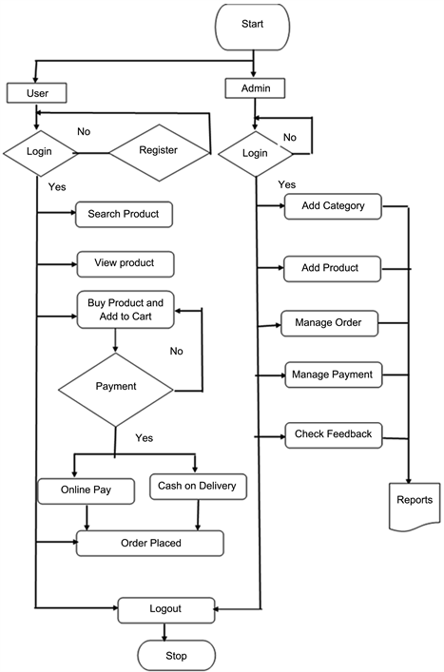

Fig 2 Process flow and functionalities.

**PROCESS FLOW:**

* After developing the basic site structure using HTML
* Style the page using CSS and bootstrap the CSS files for UI design implementation.
* Use JavaScript to implement the core functionality and push the project work to host through the web service portal.

**FUNCTIONALITIES:**

* When user starts running the web service portal, client is asked for login details when the entered input matches with the registration database, logins as client else returns to the login page.
* After the successful login, client is now able to search, view, and buy the product by adding it to the cart.
* From the cart to order confirmation, page next proceeds to the payment site with options - online pay and cash on delivery with user input order further proceeds to placed order status.
* During the startup of portal, as choosing with admin login the same verification of admin registration details proceeds.
* After the successful login to admin panel, administrator has permissions to add products, categories, & manage orders and details of each user, feedbacks and reports.

# CHAPTER 4 RESULTS

## 3.1 Implementation:

## Open XAMPP, start Apache server and MySQL server. After

## the successful port number indication, open chrome browser navigate to <http://localhost/phpmyadmin> and create a database named E-Commerce-PHP. After the successful database creation import the database(.sql) file. Now navigate to the <http://localhost/E-Commerce-PHP> , hence project now runs in the browser with local hosting.

## 3.2 Results and Discussions:

After implementing all the functionalities and modules, the result of the E-Commerce web-based application now implemented successfully. Now the application runs with homepage of the designed e-commerce website from client-side portal. Consumer or the client can now be able to register their own account with details like email, phone number password for login.

After the successful login customers can see the products, surf and add to the cart for further checkout and order placement. As of in admin panel, administrator manages the product details, customer details and the orders placed in the portal.

# CHAPTER 5 CONCLUSION

## CONCLUSION

After completing all the milestones, we have our application ready to be deployed and hosted live onto the web. Start off by pushing your code to your GitHub account with a good README.md to publish your project. Host your app locally live using XAMPP and PHP web portal service or globally using Netlify and share its link among your peers.

## 5.1 FUTURE WORKS

Since the e-commerce is a booming area of social life, daily update in the markets and commerce fields are very much mandatory. Futuristic works or add-on versions will be based on the bug free and more stable website. Updating the web UI designs more elegant and user friendly.

# CHAPTER 6 REFERENECES

## REFERENCES

* <https://www.bigcommerce.com/blog/build-an-ecommerce-website/#how-to-build-an-ecommerce-website-step-by-step>
* <https://youtu.be/Vdo2fSMfUVM>
* <https://dev.to/kunaal438/how-to-make-an-e-commerce-website-with-html-css-and-js-3aon>
* ABC’S of JavaScript reference book by Purcell.
* JavaScript pocket reference,3rd edition by David Flanagan, publishers O'Reilly Media, Inc.
* UML idea. access 1.05.2018 <https://en.wikipedia.org/wiki/Unified_Modeling_Language>.
* <http://www.modelrumahminimalis.co/html-menu-templates-freedownload/69033.html/top-result-html-menu-templates-free-download-inspirationalgenerous-menu-template-html-images-entry-level-resume-templates-picture-2017-hdj5>.
* 1. Anne Boehm, Joel Murach, Murach’s ASP.NET 4 Web Programming with C# 2010, 4th Edition, Murach, 2010.
* Bryan Syverson, Joel Murach, Murach’s SQL Server 2012 for developers, Murach, 2012

## APPENDICES

### 7. 1. APPENDIX- 1

#### SCREEN SHOTS

#### ADMIN PANEL:

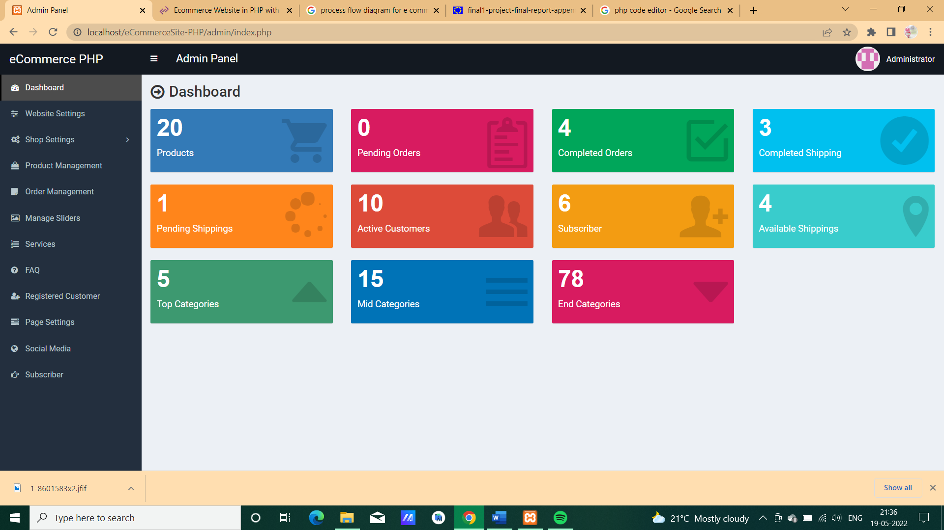

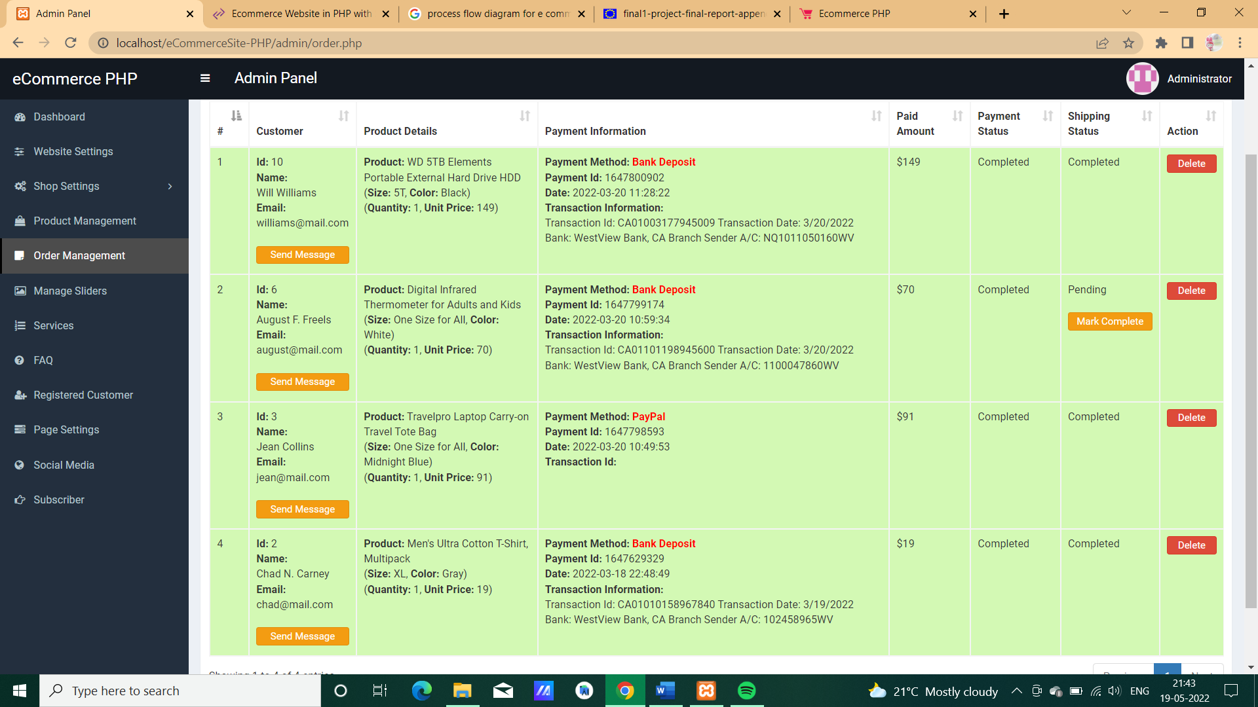

**Fig 3 Outcome admin panel.**

**16**

**CLIENT PANEL:**

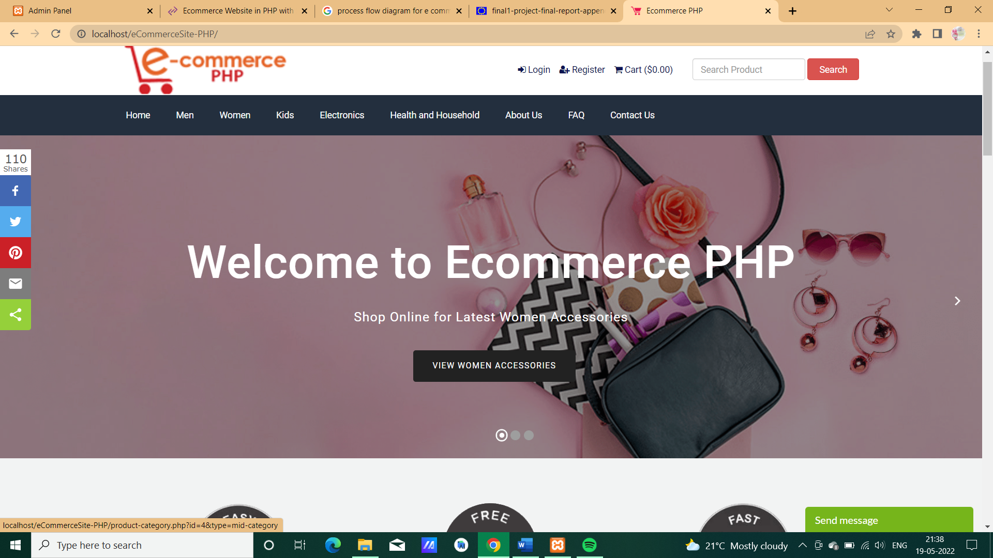

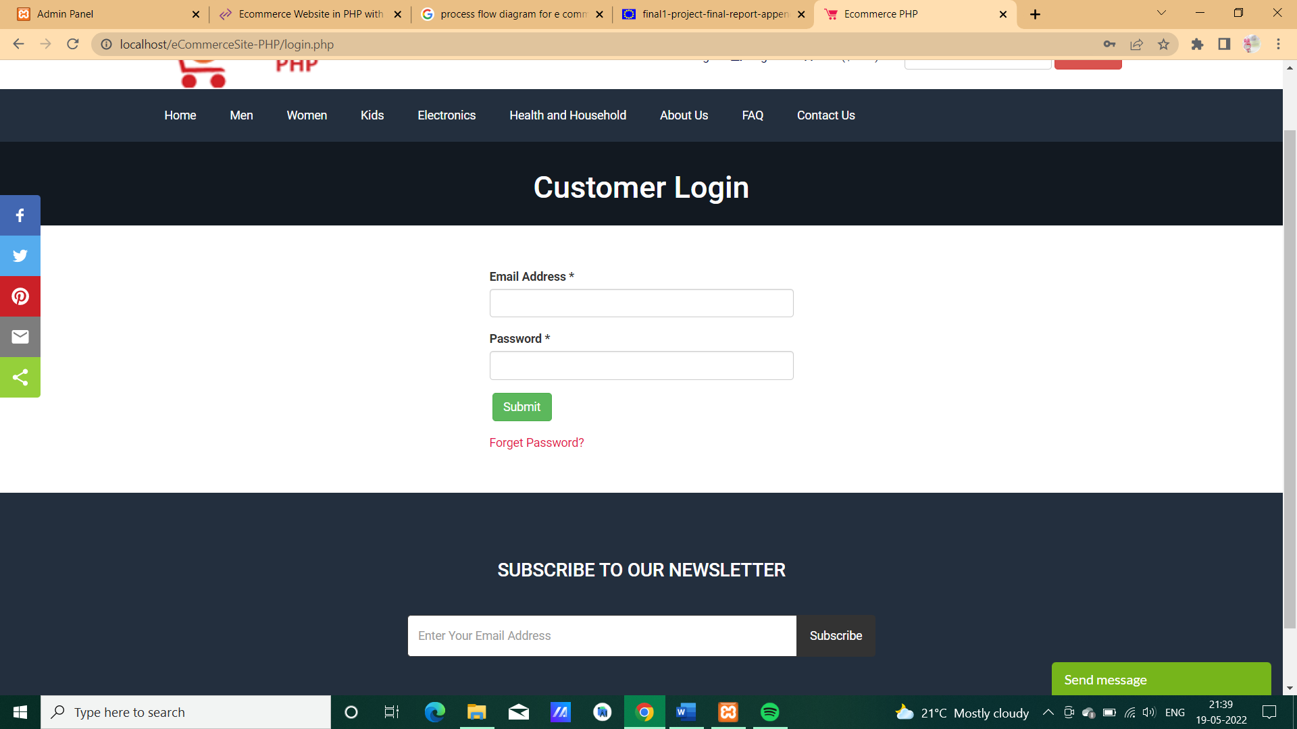

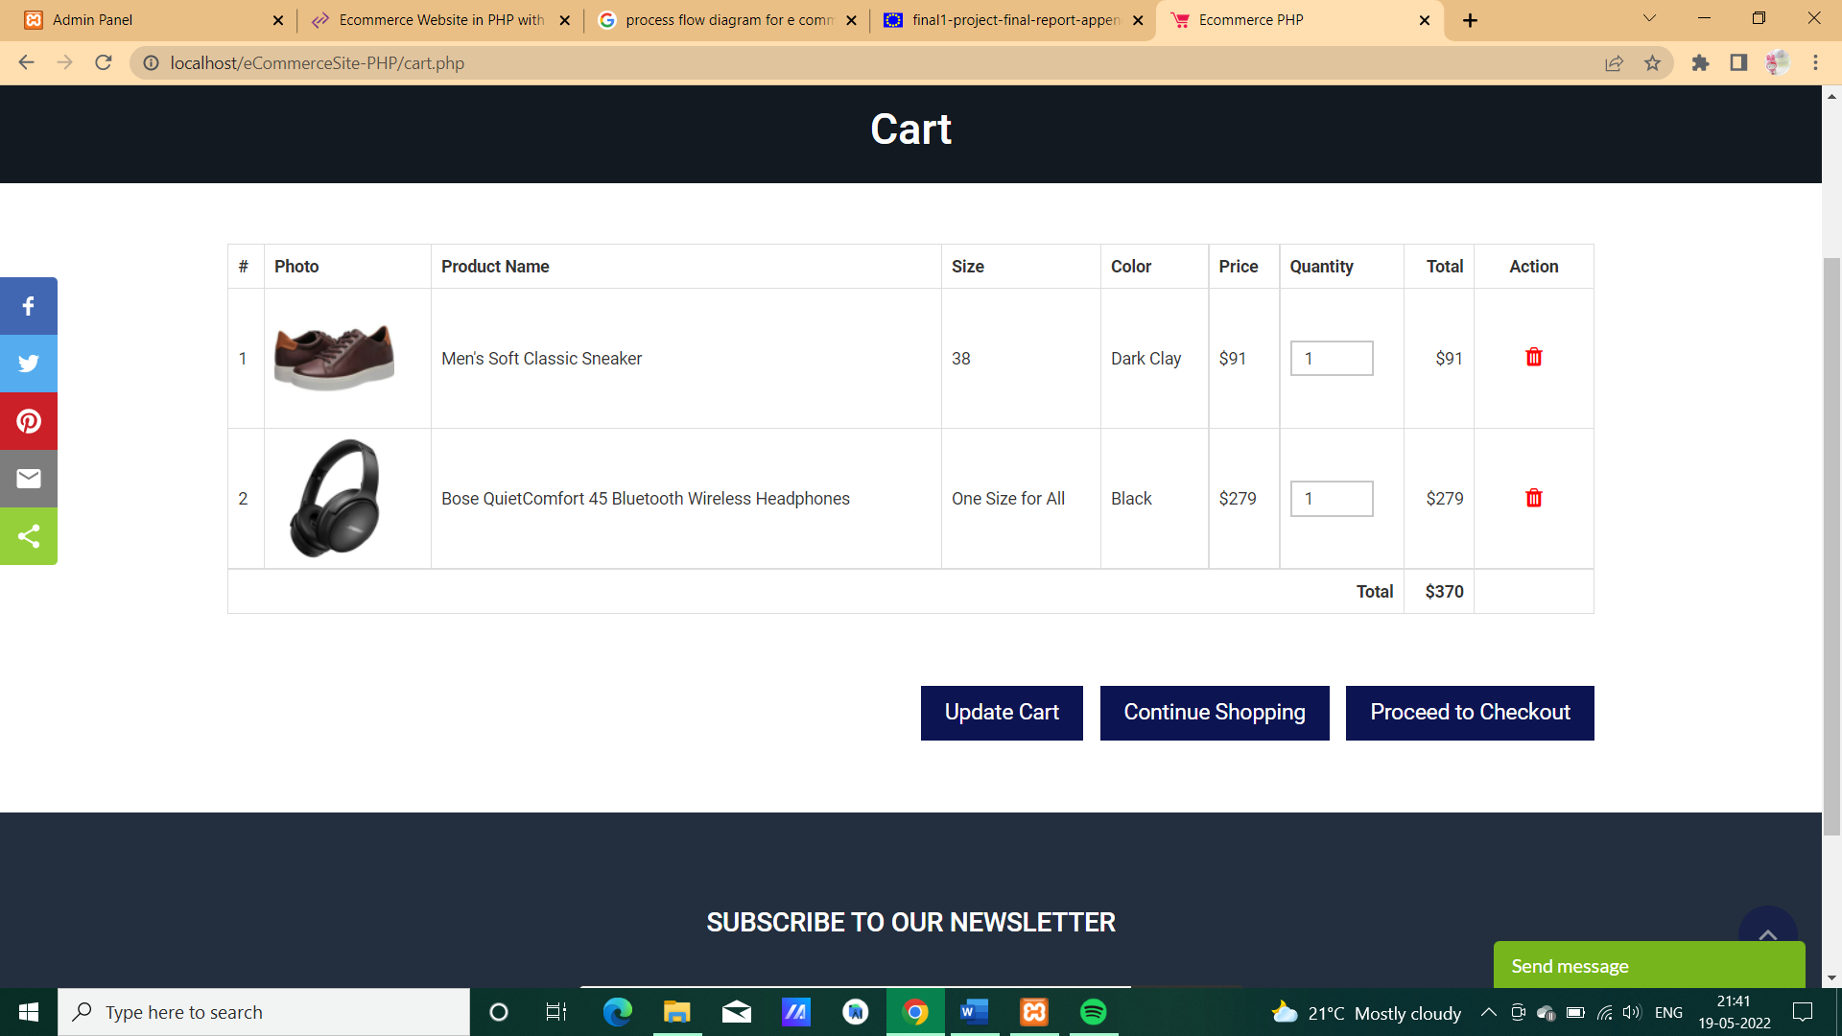

**Fig 4 Client control panel and options**

### 7. 2. APPENDIX- 2

#### CODING

**CSS**

@import url("https://fonts.googleapis.com/css?family=Roboto:400,500,700");

body {

font-size: 13px;

font-family: "Roboto", sans-serif;

}

.info-box-text {

white-space: normal !important;

}

.error {

color: red;

border: 0;

background: 0;

padding: 0;

margin-bottom: 10px;

}

.video-iframe iframe {

width: 100%;

height: 200px;

}

select.form-control {

padding-top: 2px;

}

.navbar-nav > .user-menu .user-image {

width: 40px;

height: 40px;

margin-top: -10px;

}

.login-logo {

font-size: 20px;

}

18

.login-logo b {

font-size: 28px;

}

.content-header > h1,

.content-header .content-header-left h1 {

font-family: "Roboto", sans-serif;

}

.main-header .logo {

text-align: left;

}

.main-header .logo .logo-lg {

font-family: "Roboto", sans-serif;

}

.sidebar-mini.sidebar-collapse .main-header .logo > .logo-mini {

margin-left: 0;

}

.info-box-number {

font-size: 34px;

}

.garment-label-heading {

text-align: left;

font-weight: bold;

background: #eee;

padding: 10px 15px;

border-radius: 4px;

}

.garment-label {

color: #d43f3a;

display: block;

margin-top: 10px;

font-weight: bold;

}

.dropdown-menu {

min-width: auto;

}

.disable-click {

pointer-events: none !important;

}

19

.box-info {

padding-top: 20px;

}

.content-header > h1 {

position: relative;

padding-left: 30px;

}

.content-header > h1:before {

position: absolute;

top: 0;

left: 0;

font-family: "FontAwesome", sans-serif;

font-size: 26px;

content: "\f18e";

}

.sidebar-menu li.active > a > .pull-right-container > .fa-angle-left {

-webkit-transform: rotate(90deg);

-ms-transform: rotate(90deg);

-o-transform: rotate(90deg);

transform: rotate(90deg);

}

.sidebar-menu li > a > .pull-right-container > .fa-angle-left:before {

content: "\f105";

}

h4.modal-title {

color: #3c8dbc;

font-weight: bold;

}

.rTable {

display: table;

width: 100%;

border: 1px solid #999999;

}

.rTableRow {

display: table-row;

}

.rTableHeading {

display: table-header-group;

background-color: #ddd;

}

20

.rTableHead {

width: 40%;

}

.rTableCell,

.rTableHead {

display: table-cell;

padding: 3px 10px;

border: 1px solid #999999;

}

.rTableHeading {

display: table-header-group;

background-color: #ddd;

font-weight: bold;

}

.rTableFoot {

display: table-footer-group;

font-weight: bold;

background-color: #ddd;

}

.rTableBody {

display: table-row-group;

}

.content-header {

overflow: hidden;

}

.content-header .content-header-left {

float: left;

padding-top: 5px;

}

.content-header .content-header-right {

float: right;

}

.content-header .content-header-left h1 {

margin-top: 0;

margin-bottom: 0;

padding-left: 30px;

padding-bottom: 5px;

font-size: 24px;

position: relative;

}

.content-header .content-header-left h1:before {

position: absolute;

top: 0;

left: 0;

font-family: "FontAwesome", sans-serif;

21

font-size: 26px;

content: "\f18e";

}

.content-header .content-header-right a {

position: relative;

/*padding-left: 24px;*/

font-size: 14px;

}

.content-header .content-header-right a:before {

/*position: absolute;

top: 4px;

left: 5px;

font-family: 'FontAwesome', sans-serif;

font-size: 16px;

content: '\f067';*/

}

.checkbox-inline {

padding-top: 0 !important;

}

.checkbox-content {

float: left;

border: 1px solid #aaa;

margin-right: 5px;

margin-bottom: 5px;

padding-left: 5px;

padding-right: 5px;

padding-bottom: 3px;

}

.checkbox-content.role-access {

float: none;

border: 0;

}

.skin-blue .sidebar-menu > li:hover > a,

.skin-blue .sidebar-menu > li.active > a {

color: #fff;

background: #3c8dbc;

border-left-color: #3c8dbc;

}

.pt10 {

padding-top: 10px;

}

.pt20 {

22

padding-top: 20px;

}

.ml10 {

margin-left: 10px;

}

img.existing-photo {

max-width: 500px;

}

.slimScrollBar {

background: none repeat scroll 0 0 #9e9e9e !important;

border-radius: 0;

display: none;

height: 702.936px;

position: absolute;

right: 1px;

top: 145px;

width: 10px !important;

z-index: 99;

opacity: 0.7 !important;

}

.seo-info {

font-family: "Cairo", sans-serif;

color: red;

font-weight: 700;

font-size: 16px;

background: #e4e4e4;

padding: 15px;

}

.skin-blue .main-header .logo,

.skin-blue .main-header .logo:hover,

.skin-blue .main-header .navbar,

.skin-blue .main-header .navbar .sidebar-toggle:hover {

/* background-color: #333333; */

background-color: #131921;

}

.skin-blue .sidebar-menu > li:hover > a,

.skin-blue .sidebar-menu > li.active > a {

background-color: #4c4c4c;

border-left-color: #000000;

}

23

.nav-tabs-custom > .nav-tabs > li.active {

border-top-color: #333333;

}

.box.box-info {

border-top-color: #4c4c4c;

}

.user-footer div {

width: 100%;

}

.user-footer div:first-child {

margin-bottom: 10px;

}

.user-footer div a {

display: block;

}

.navbar-nav > .user-menu > .dropdown-menu {

width: 140px;

}

.navbar-nav > .user-menu > .dropdown-menu > .user-footer {

background-color: #d6d6d6;

}

.content-header .content-header-right a {

background-color: #333333;

border-color: #333333;

}

.form-control:focus {

border-color: #333333;

}

.login-button {

background-color: #333333;

border-color: #333333;

}

iframe {

/* width: 300px!important; */

}

.sidebar-menu .treeview-menu > li > a {

font-size: 12px;

}

24

input,

textarea,

select {

font-size: 13px !important;

}

.bg-g {

background: #d3f9b4 !important;

}

.bg-r {

background: #f9cccc !important;

}

**Javascript**

**The main javascript file**

/*! AdminLTE app.js

* ================

* Main JS application file for AdminLTE v2. This file

* should be included in all pages. It controls some layout

* options and implements exclusive AdminLTE plugins.

function _init(){"use strict";$.AdminLTE.layout={activate:function(){var a=this;a.fix(),a.fixSidebar(),$(window,".wrapper").resize(function(){a.fix(),a.fixSidebar()})},fix:function(){var a=$(".main-header").outerHeight()+$(".main-footer").outerHeight(),b=$(window).height(),c=$(".sidebar").height();if($("body").hasClass("fixed"))$(".content-wrapper, .right-side").css("min-height",b-$(".main-footer").outerHeight());else{var d;b>=c?($(".content-wrapper, .right-side").css("min-height",b-a),d=b-a):($(".content-wrapper, .right-side").css("min-height",c),d=c);var e=$($.AdminLTE.options.controlSidebarOptions.selector);"undefined"!=typeof e&&e.height()>d&&$(".content-wrapper, .right-side").css("min-height",e.height())}},fixSidebar:function(){return $("body").hasClass("fixed")?("undefined"==typeof $.fn.slimScroll&&window.console&&window.console.error("Error: the fixed layout requires the slimscroll plugin!"),void($.AdminLTE.options.sidebarSlimScroll&&"undefined"!=typeof $.fn.slimScroll&&($(".sidebar").slimScroll({destroy:!0}).height("auto"),$(".sidebar").slimscroll({height:$(window).height()-$(".main-header").height()+"px",color:"rgba(0,0,0,0.2)",size:"3px"})))):void("undefined"!=typeof $.fn.slimScroll&&$(".sidebar").slimScroll({destroy:!0}).height("auto"))}},$.AdminLTE.pushMenu={activate:function(a){var b=$.AdminLTE.options.screenSizes;$(document).on("click",a,function(a)

25

{a.preventDefault(),$(window).width()>b.sm-1?$("body").hasClass("sidebar-collapse")?$("body").removeClass("sidebar-collapse").trigger("expanded.pushMenu"):$("body").addClass("sidebar-collapse").trigger("collapsed.pushMenu"):$("body").hasClass("sidebar-open")?$("body").removeClass("sidebar-open").removeClass("sidebar-collapse").trigger("collapsed.pushMenu"):$("body").addClass("sidebar-open").trigger("expanded.pushMenu")}),$(".content-wrapper").click(function(){$(window).width()<=b.sm-1&&$("body").hasClass("sidebar-open")&&$("body").removeClass("sidebar-open")}),($.AdminLTE.options.sidebarExpandOnHover||$("body").hasClass("fixed")&&$("body").hasClass("sidebar-mini"))&&this.expandOnHover()},expandOnHover:function(){var a=this,b=$.AdminLTE.options.screenSizes.sm-1;$(".main-sidebar").hover(function(){$("body").hasClass("sidebar-mini")&&$("body").hasClass("sidebar-collapse")&&$(window).width()>b&&a.expand()},function(){$("body").hasClass("sidebar-mini")&&$("body").hasClass("sidebar-expanded-on-hover")&&$(window).width()>b&&a.collapse()})},expand:function(){$("body").removeClass("sidebar-collapse").addClass("sidebar-expanded-on-hover")},collapse:function(){$("body").hasClass("sidebar-expanded-on-hover")&&$("body").removeClass("sidebar-expanded-on-hover").addClass("sidebar-collapse")}},$.AdminLTE.tree=function(a){var b=this,c=$.AdminLTE.options.animationSpeed;$(document).off("click",a+" li a").on("click",a+" li a",function(a){var d=$(this),e=d.next();if(e.is(".treeview-menu")&&e.is(":visible")&&!$("body").hasClass("sidebar-collapse"))e.slideUp(c,function(){e.removeClass("menu-open")}),e.parent("li").removeClass("active");else if(e.is(".treeview-menu")&&!e.is(":visible")){var f=d.parents("ul").first(),g=f.find("ul:visible").slideUp(c);g.removeClass("menu-open");var h=d.parent("li");e.slideDown(c,function(){e.addClass("menu-open"),f.find("li.active").removeClass("active"),h.addClass("active"),b.layout.fix()})}e.is(".treeview-menu")&&a.preventDefault()})},$.AdminLTE.controlSidebar={activate:function(){var a=this,b=$.AdminLTE.options.controlSidebarOptions,c=$(b.selector),d=$(b.toggleBtnSelector);d.on("click",function(d){d.preventDefault(),c.hasClass("control-sidebar-open")||$("body").hasClass("control-sidebar-open")?a.close(c,b.slide):a.open(c,b.slide)});var e=$(".control-sidebar-bg");a._fix(e),$("body").hasClass("fixed")?a._fixForFixed(c):$(".content-wrapper, .right-side").height()<c.height()&&a._fixForContent(c)},open:function(a,b){b?a.addClass("control-sidebar-open"):$("body").addClass("control-sidebar-open")},close:function(a,b){b?a.removeClass("control-sidebar-open"):$("body").removeClass("control-sidebar-open")},_fix:function(a){var b=this;if($("body").hasClass("layout-boxed")){if(a.css("position","absolute"),a.height($(".wrapper").height()),b.hasBindedResize)return;$(window).resize(function(){b._fix(a)}),b.hasBindedResize=!0}else a.css({position:"fixed",height:"auto"})}

26

,_fixForFixed:function(a){a.css({position:"fixed","max-height":"100%",overflow:"auto","padding-bottom":"50px"})},_fixForContent:function(a){$(".content-wrapper, .right-side").css("min-height",a.height())}},$.AdminLTE.boxWidget={selectors:$.AdminLTE.options.boxWidgetOptions.boxWidgetSelectors,icons:$.AdminLTE.options.boxWidgetOptions.boxWidgetIcons,animationSpeed:$.AdminLTE.options.animationSpeed,activate:function(a){var b=this;a||(a=document),$(a).on("click",b.selectors.collapse,function(a){a.preventDefault(),b.collapse($(this))}),$(a).on("click",b.selectors.remove,function(a){a.preventDefault(),b.remove($(this))})},collapse:function(a){var b=this,c=a.parents(".box").first(),d=c.find("> .box-body, > .box-footer, > form >.box-body, > form > .box-footer");c.hasClass("collapsed-box")?(a.children(":first").removeClass(b.icons.open).addClass(b.icons.collapse),d.slideDown(b.animationSpeed,function(){c.removeClass("collapsed-box")})):(a.children(":first").removeClass(b.icons.collapse).addClass(b.icons.open),d.slideUp(b.animationSpeed,function(){c.addClass("collapsed-box")}))},remove:function(a){var b=a.parents(".box").first();b.slideUp(this.animationSpeed)}}}if("undefined"==typeof jQuery)throw new Error("AdminLTE requires jQuery");$.AdminLTE={},$.AdminLTE.options={navbarMenuSlimscroll:!0,navbarMenuSlimscrollWidth:"3px",navbarMenuHeight:"200px",animationSpeed:500,sidebarToggleSelector:"[data-toggle='offcanvas']",sidebarPushMenu:!0,sidebarSlimScroll:!0,sidebarExpandOnHover:!1,enableBoxRefresh:!0,enableBSToppltip:!0,BSTooltipSelector:"[data-toggle='tooltip']",enableFastclick:!1,enableControlSidebar:!0,controlSidebarOptions:{toggleBtnSelector:"[data-toggle='control-sidebar']",selector:".control-sidebar",slide:!0},enableBoxWidget:!0,boxWidgetOptions:{boxWidgetIcons:{collapse:"fa-minus",open:"fa-plus",remove:"fa-times"},boxWidgetSelectors:{remove:'[data-widget="remove"]',collapse:'[data-widget="collapse"]'}},directChat:{enable:!0,contactToggleSelector:'[data-widget="chat-pane-toggle"]'},colors:{lightBlue:"#3c8dbc",red:"#f56954",green:"#00a65a",aqua:"#00c0ef",yellow:"#f39c12",blue:"#0073b7",navy:"#001F3F",teal:"#39CCCC",olive:"#3D9970",lime:"#01FF70",orange:"#FF851B",fuchsia:"#F012BE",purple:"#8E24AA",maroon:"#D81B60",black:"#222222",gray:"#d2d6de"},screenSizes:{xs:480,sm:768,md:992,lg:1200}},$(function(){"use strict";$("body").removeClass("hold-transition"),"undefined"!=typeof AdminLTEOptions&&$.extend(!0,$.AdminLTE.options,AdminLTEOptions);var a=$.AdminLTE.options;_init(),$.AdminLTE.layout.activate(),$.AdminLTE.tree(".sidebar"),a.enableControlSidebar&&$.AdminLTE.controlSidebar.activate(),a.navbarMenuSlimscroll&&"undefined"!=typeof $.fn.slimscroll&&$(".navbar .menu").slimscroll({height:a.navbarMenuHeight,alwaysVisible:!1,size:a.navbarMenuSlimscrollWidth}).css("width","100%"),a.sidebarPushMenu&&$.AdminLTE.pushMenu.activate(a.sidebarToggleSelector),a.enableBSToppltip&&$("body").tooltip({selector:a.BSTooltipSelector}),a.enableBoxWidget&&$.AdminLTE.boxWidget.activate(),a.enableFastclick&&"undefined"!=typeof FastClick&&FastClick.attach(document.body),a.directChat.enable&&$(document).on("click",a.directChat.contactToggleSelector,function(){var a=$(this).parents(".direct-chat").first();a.toggleClass("direct-chat-contacts-open")}),$('.btn-group[data-toggle="btn-toggle"]').

27

each(function(){var a=$(this);$(this).find(".btn").on("click",function(b){a.find(".btn.active").removeClass("active"),$(this).addClass("active"),b.preventDefault()})})}),function(a){"use strict";a.fn.boxRefresh=function(b){function c(a){a.append(f),e.onLoadStart.call(a)}function d(a){a.find(f).remove(),e.onLoadDone.call(a)}var e=a.extend({trigger:".refresh-btn",source:"",onLoadStart:function(a){return a},onLoadDone:function(a){return a}},b),f=a('<div class="overlay"><div class="fa fa-refresh fa-spin"></div></div>');return this.each(function(){if(""===e.source)return void(window.console&&window.console.log("Please specify a source first - boxRefresh()"));var b=a(this),f=b.find(e.trigger).first();f.on("click",function(a){a.preventDefault(),c(b),b.find(".box-body").load(e.source,function(){d(b)})})})}}(jQuery),function(a){"use strict";a.fn.activateBox=function(){a.AdminLTE.boxWidget.activate(this)},a.fn.toggleBox=function(){var b=a(a.AdminLTE.boxWidget.selectors.collapse,this);a.AdminLTE.boxWidget.collapse(b)},a.fn.removeBox=function(){var b=a(a.AdminLTE.boxWidget.selectors.remove,this);a.AdminLTE.boxWidget.remove(b)}}(jQuery),function(a){"use strict";a.fn.todolist=function(b){var c=a.extend({onCheck:function(a){return a},onUncheck:function(a){return a}},b);return this.each(function(){"undefined"!=typeof a.fn.iCheck?(a("input",this).on("ifChecked",function(){var b=a(this).parents("li").first();b.toggleClass("done"),c.onCheck.call(b)}),a("input",this).on("ifUnchecked",function(){var b=a(this).parents("li").first();b.toggleClass("done"),c.onUncheck.call(b)})):a("input",this).on("change",function(){var b=a(this).parents("li").first();b.toggleClass("done"),a("input",b).is(":checked")?c.onCheck.call(b):c.onUncheck.call(b)})})}}(jQuery);

28